Intuitive Yoga with Eleanora Lipton (USA)
June 28th – 30th 2019
To Be Held at Practice for Energy, Health and Education
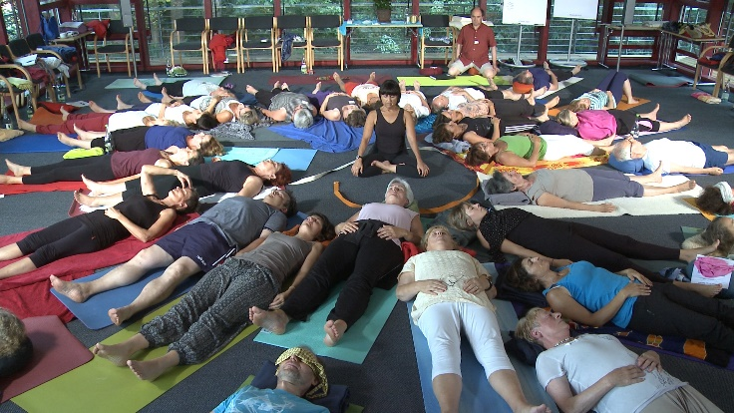
Euskirchen, Germany
Do you experience stiffness and pain in your body?
Want to learn how to move with flexibility and ease?
You have the capacity to create the body and wellness you desire!
Intuitive Yoga is a simple process of directing breath and energy into areas of pain, tightness and limitation. Utilizing the patterns of elemental energies as taught in Polarity Therapy, blockages in the body experiencing stiffness and pain can be nourished by the energy moving in and through the corresponding areas.
My teacher Eleanora Lipton offers this introductory workshop to both beginners and advanced - anyone desiring the opportunity to experience themselves on a deeper level.
In this Workshop, you will learn how to:
- Use the asanas of Hatha Yoga along with the energy principles of Dr. Randolph Stone's Polarity Therapy to open vitality in your body, cultivating intuition, and accessing Source.
- Turn your attention to the places of ease, the areas where the life force is moving, and miracles of movement happen.
- Direct that energy into the area you wish to move more freely. Guiding the process in this way is what you will experience and see demonstrated
Space is limited to 20 mats
Cost of Workshop 195 € 220 € on day of event (if space available)
Location: Practice and Seminar Room for Energy, Health and Education.
Bachstrasse 21, 53881 Euskirchen - Kuchenheim (250 m from Euskirchen-Bonn railway station)
Contact Peter Rhiem with any questions, email: peterrhiem@posteo.de Tel.: 02251 - 91 75 99 6
Register at http://www.energie-gesundheit-bildung.de/termine/
Eleanora Lipton is the founder of Intuitive Yoga, with over 30 years experience in Hatha Yoga, Polarity Therapy and Meditation. She gives yoga and meditation retreats and private sessions in the USA and internationally.
www.pathsforwholeness.com

